Activity 2.2.3: It’s all in the Reflexes

Introduction
Although we are all different and have our unique identity, there are times when we behave in exactly the same way. We blink if something is headed toward our eyes. We pull our hands away quickly if we touch something hot or sharp. The automatic response of a muscle to a stimulus is called a reflex. This action is controlled by the human nervous system and is considered an involuntary response – it happens without our even having to think about it. On the other hand, voluntary responses occur when we have to think to react. It is possible to stop a reflex reaction, but it would take a lot of voluntary control.

A good example of a reflex is the “knee-jerk” response the doctor tests during a physical examination. In a healthy person, this stretch reflex maintains posture and allows our muscles to hold up our body. Doctors can check this reflex by tapping on the tendon just below the kneecap. This tap causes contraction of the quadriceps muscle and extension of the leg. Stretching of the muscle activates nerve impulses which travel to the spinal cord. Here the incoming impulses activate motor neurons, which travel back to the muscle and result in muscle contraction.

In this activity you will use an EKG sensor and a measuring device called an accelerometer to compare the speed of voluntary versus reflex muscle action. Just as it can measure the electrical activity of your heart, the EKG sensor will measure the electrical activity in a moving muscle. When we record the electrical activity in muscles, we call this reading an electromyogram or EMG. You will make a rough calculation of nerve impulse speed using data generated by an accelerometer and the EKG sensor. As you analyze data for response times, you will also investigate what has to occur in the nervous system during a reflex and a voluntary action.

Equipment
- Computer with Vernier Logger Pro® software
- Vernier LabQuest® Mini with USB cable
- Vernier EKG sensor with adhesive pads
- Vernier 25-g Accelerometer
- Reflex hammer
- Rubber bands
- Laboratory journal
- Tape measure
- Alcohol wipes (optional)

Procedure
The following is used with permission of Vernier Software and Technology. This activity is adapted from the book Human Physiology with Vernier, written by Diana Gordon and Steven L. Gordon, M.D.
Part I - Voluntary Activation of the Quadriceps Muscle
Each person in the group will take turns being subject and tester. In this part of the activity, the subject will respond to a sound by kicking out his/her leg. Think about this kick as if you were a soccer player who has been instructed to kick when he or she hears a whistle blow.

- Create the following data tables in your laboratory journal.
Table 1
 | Kick 1 | Kick 2 | Kick 3 | Kick 4 | Kick 5 | Average
Time of muscle contraction (s)
Time of stimulus (s)
Δt (s)

Table 2
 | Reflex 1 | Reflex 2 | Reflex 3 | Reflex 4 | Reflex 5 | Average
Time of muscle contraction (s)
Time of stimulus (s)
Δt (s)

- Click on File Open and open the Human Physiology with Vernier folder.
- Open the program titled 14A Reflexes with ACC.
- Connect the EKG sensor into CH 1 and the accelerometer to CH 2 of the LabQuest Mini.
- Connect the LabQuest Mini to the computer using the USB cable.
- Connect the Accelerometer to the reflex hammer using rubber bands, as shown below. Place the Accelerometer cable toward the back of the hammer so it does not get in the way. Your teacher may have already completed this step for you.
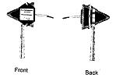
- Have the subject sit comfortably in a chair that is high enough to allow the legs to dangle freely above the floor. The subject may have to sit on the desk to ensure that the leg can swing freely.
- Attach two electrode tabs above one knee along the line of the quadriceps muscle between the knee and the hip. The tabs should be 5 cm and 13 cm from the middle of the patella. Place a third electrode tab on the lower leg.
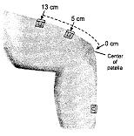
- Attach the red and green leads to the electrode tabs above the knee with the red electrode closest to the knee. Attach the black lead (ground) to the electrode tab on the lower leg. NOTE: If you find that you are not getting a good signal, consider moving the ground electrode to your wrist. Your signal will be better if you can minimize movement of the wires.
- When the subject’s leg is still, click the green Collect arrow on the toolbar to begin data collection. Let the data collection continue for approximately 10 seconds. If the EMG graph has a stable baseline (as shown below), click the red Stop button and continue to Step 11. If the graph has an unstable baseline, click the red Stop button and collect a new set of data by clicking the green Collect button again. You may need to adjust the leads on the leg to obtain a stable baseline. If directed to do so by your teacher, swab the area with alcohol wipes to free the skin from oils and lotions. Depending on your connection, the baseline on the EMG graph may appear as a line or as a thicker band. Repeat data collection until you have obtained a stable baseline for 10 s.
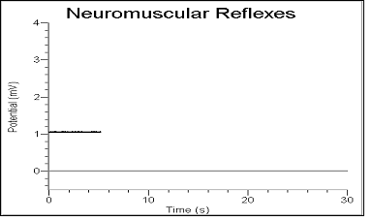
- Now you will collect voluntary activation data. Note: Read the entire step before collecting data to familiarize yourself with the procedure.
- Have the subject close their eyes or avert them from the screen.

- Click the green Collect arrow.

- After recording 5 s of stable baseline, swing the reflex hammer briskly to contact the table or other surface that generates a sound. Make sure the arrow on the accelerometer is pointed upward.

- Have the subject kick the leg out immediately upon hearing the sound.

- Continue obtaining reflexes (repeat parts c and d of this step) so that you record 5-10 kicks during the data-collection period. Allow 5-10 seconds between each swing of the hammer so that you can clearly see each response.

- When you have completed the trial, see that combined data will appear on the bottom graph. You may click the red Stop button at any point to end the trial.

- Name and save the file when instructed to do so. Follow your teacher’s instructions regarding the file name and location to save the file.

- Determine the time elapsed between striking the table surface with the reflex hammer and the contraction of the quadriceps muscle.
- Refer to the EMG and Acceleration graphs.

- Click the Examine button and place your cursor somewhere on the Acceleration graph.

- Align the examine line with the first high peak, which corresponds with the first hammer strike in the Acceleration graph. This peak indicates the time the table surface was struck. Record this time in Table 1.
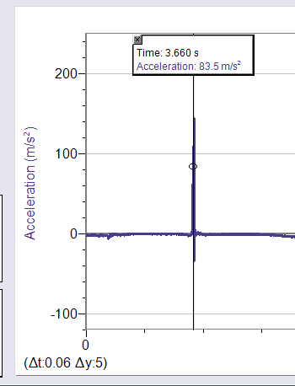

- Move the cursor to the EMG graph and align the examine line with the first high peak in the graph. This peak indicates the time at which the quadriceps muscle contracted. Record this time in Table 1.
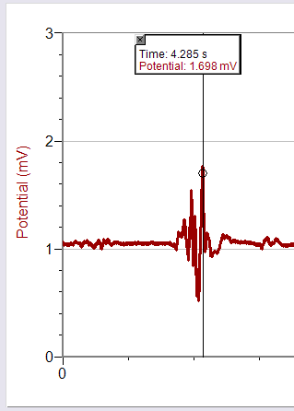
- Repeat this process and determine the time of the hammer strike and reflex for a total of five stimulus-kick pairs.
- Calculate the change in time between the hammer strike and reflex for the five stimulus-kick pairs. Calculate the average change in time for all five pairs. Record the values in Table 1.

Part II - Patellar Reflex
Each person in the group will take turns being subject and tester. In this part of the activity, you will activate the patellar reflex and measure the time it takes for the quadriceps to respond.

- Locate the subject's patellar tendon by feeling for the narrow band of tissue that connects the lower aspect of the patella to the tibia. Refer to your skeletal system graphic organizer or your Maniken® if you have trouble locating the patella. Place a pen mark in the center of the tendon, which can be identified by its softness compared with the bones above and below.
- Test the patellar reflex before you begin data collection. Swing the hammer briskly to contact the mark on the subject’s tendon. Adjust your swing until you see a marked response.
- Note that the EKG leads should be attached as in Part I.
- Click the green Collect arrow to begin data collection. Find a stable baseline as you did in Step 10.
- Collect patellar reflex data. Note: Read the entire step before collecting data to familiarize yourself with the procedure.
- Have the subject close their eyes or avert them from the screen.

- Click the green Collect arrow.

- After recording 5 s of stable baseline, swing the reflex hammer briskly to contact the mark on the subject's tendon. You should see the leg react.

- Continue obtaining reflexes so that you record 5-10 reflexes during the collection period. Allow 5-10 seconds between each swing of the hammer so that you can clearly see each response.

- When you have completed the trial, click the red Stop button.

- Name and save the file when instructed to do so. Follow your teacher’s instructions regarding the file name and location to save the file.

- Determine the time elapsed between striking the patellar tendon with the reflex hammer and the contraction of the quadriceps muscle. Follow the same procedure you used in Step 13.
- Repeat the process of determining the time of the hammer strike and reflex for a total of five stimulus-kick pairs.
- Record this data in Data Table 2.
- Compare the average time interval from Part I and Part II.
- Use the Internet to research the flow of information in the “reflex arc” seen in the patellar reflex. Determine how the nervous system works to provide you with such a speedy response.
- In your laboratory journal, draw a cross section of the spinal cord and show how the three types of neurons are involved in reflex action. Make sure to show how these neurons interface with the leg. Is the brain involved in this pathway? Why or why not?
- Complete the Conclusion questions.
Conclusion
- Compare the reaction times for voluntary vs. involuntary activation of the quadriceps muscle. What might account for the observed differences in reaction times? Outline what has to occur in the body for each reaction to occur. Refer to your drawing from Step 23. Information from the flow chart you created in Activity 2.2.1 might also be helpful.

- Suggest two ways that reflex reactions help maintain homoeostasis in the human body.

- Explain how the accelerometer and the EMG electrodes work together to generate data on response time. How does Logger Pro help you analyze this data?

- What factors impact a person’s reaction time?

Extension Questions:
- Using data from your reflex experiment, calculate the speed at which a stimulus traveled from the patellar tendon to the spinal cord and back to the quadriceps muscle (complete reflex arc). To do this, you must estimate the distance traveled. Using a cloth tape measure, measure the distance in cm from the mark on the patellar tendon to the spinal cord at waist level (straight across from the small of your back -see the figure on the next page). Multiply the distance by two to obtain the total distance traveled in the reflex arc. Once this value has been obtained, divide by the average time from the patellar reflex trial and divide by 100 to obtain the speed in m/s, at which the stimulus traveled. Show your work.
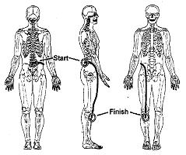

- Nerve impulses have been found to travel as fast as 100 m/s. What could account for the difference between your answer to Question 5 and this value obtained by researchers?

